Countermeasures
- The main countermeasure would be to implement a useful planner, able to gather information about the
Specific students’ needs and compare it to a database, to determine which classes and activities
Require the most time investment.
- This would also keep the student engaged, providing tips on how to maintain their new life and keep it
from being too overwhelming.

Student Motivation Loss due to disorganization

Cristian A. Ballester

1/20/2021
Problem Background
- “It is estimated that around 40% of students drop out of higher education.”
- A top reason for the loss of motivation in students is being overwhelmed by the sudden influx of
Responsibilities, with no real way to organize their new life into a way that makes sense and
Leaves enough time to have a thriving social life AND maintain their grades and academic life in order.

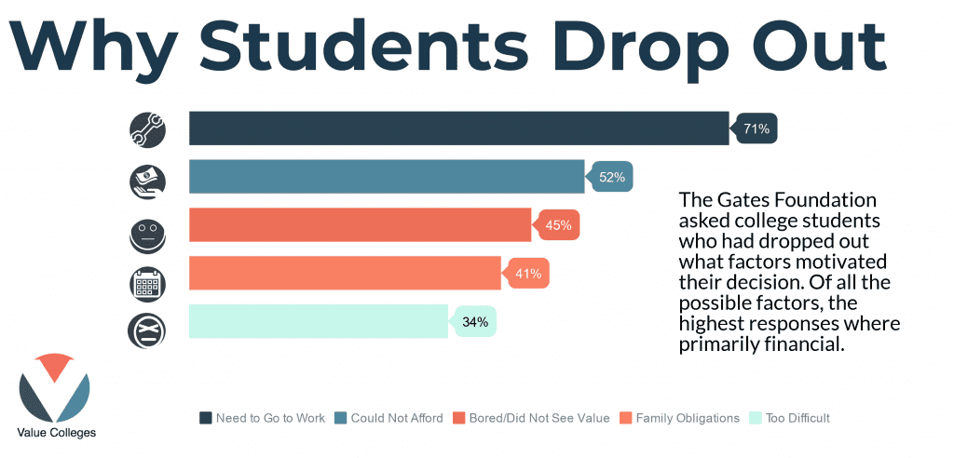

Check/Evaluate
- After implementing and allowing people to test our application, we should contact these students
To ascertain how useful our application was.
- Its important to be engaging with them through the whole process and listen to what they have to say,
Both in the result gathering stage and through the actual application itself.
- These results will probably fall into a few areas, that I am willing to see coming, so to speak.
- They could feel that this application helped keep them motivated and on top of their schoolwork,
While also being what they needed to stay ahead of their schoolwork.
- They could feel like it was helpful with organization, but it did not help keep them motivated.
- They felt it was too like other applications and therefore not helpful to them.

Causes
- Disorganization is enough of a distractor and stressor to demotivate many people.
- Most people require a clear plan and workflow to properly do their work and
Not be overwhelmed by said work.
- Many students suffer a large amount of burnout, especially in the times we live in and we should focus
On trying to retain these students by providing a way for them to get back in track.
Act/Standardize
- Depending on the feedback we receive we must be ready to change our approach tin order to accommodate to
This feedback to provide a proper web application that suits our client’s needs.
- If most of the feedback is positive, we would need to focus on the betterment of our application and if further
Features should be implemented then looking for how we would be able to implement them.
- We obviously should not be expected to scrap our project and start over, but if we miss our mark
Completely we might have to be ready to do this and start from the ground up.
Target
Provide a planner that takes into consideration things like the expected difficulty of the college courses that the
Student is enrolled in to provide a comprehensive guide and schedule to keep motivation high.
To keep the student engaged in their studies.

